**Batch: Experiment Number:**

**Roll Number: Name:**

**Aim of the Experiment:**

**Program/ Steps:**

**Output/Result:**

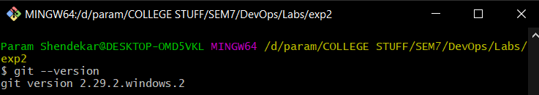

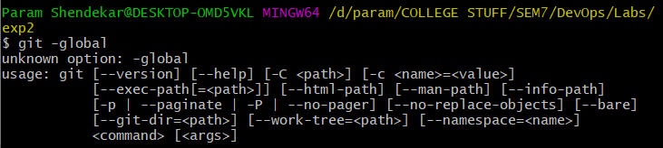



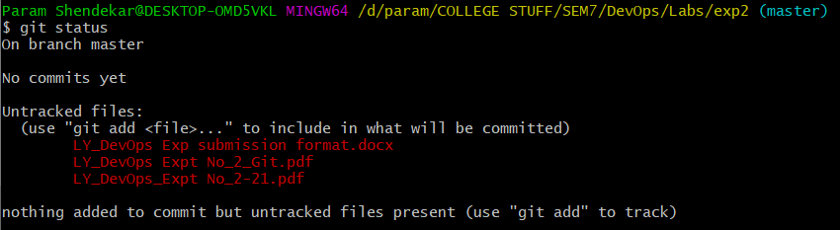

**Post Lab Question-Answers:**

**Outcomes:**

**Conclusion (based on the Results and outcomes achieved):**

**References:**